**Date: 18-10-2022 Lecture #1**

1. **Basic MCQs:**

* **Teacher Name:** Arif Butt
* **Book Name:** Operating System Concepts 10th Edition by **(Author)** Abraham Silbershatz, Peter Baer Galvin, Greg Gagne
* **TutorialsPoint** 🡪 **Online terminal for Linux**

1. **What is Operating System?**

* An operating system is a program that controls execution of application programs.
* It acts as an interface between user and hardware.
* Primary goal of OS is Convenience of user.
* Secondary goal of OS is efficient operation of program.
* Operating system is also known as Kernel.
* It is a multiuser system (used by one or more users)
* Some OS are:

1. UNIX
2. Linux
3. Sun Solaris
4. Macintosh
5. PC BSD
6. MS Windows
7. Android from Google
8. Blackberry from RIM
9. iOS from Apple
10. Symbian from Nokia
11. Windows phone from MS

* Application Programmers usually write programs that contain data from external source, process data and give output to external source.

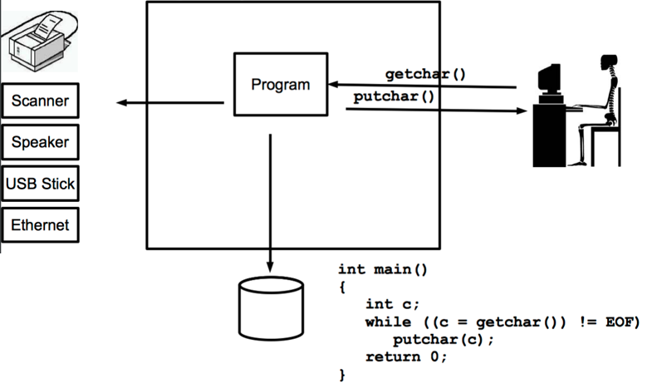

* Role of Operating system is to manage all resources (like users, devices, programs, disk files and connections), and to connect various devices to correct program.

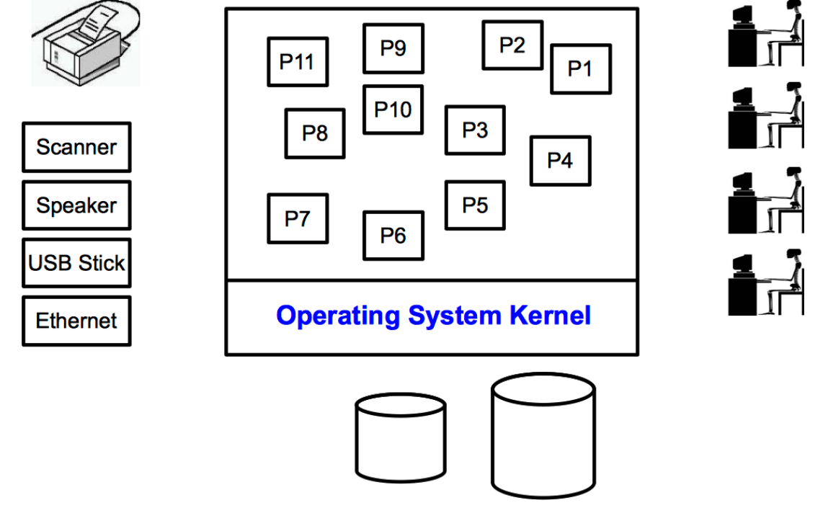

* All the connections of devices are made by kernel.
* An Operating system provides program request services through its API.

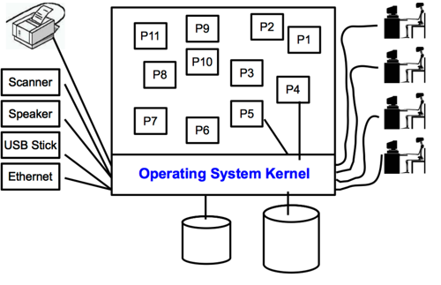

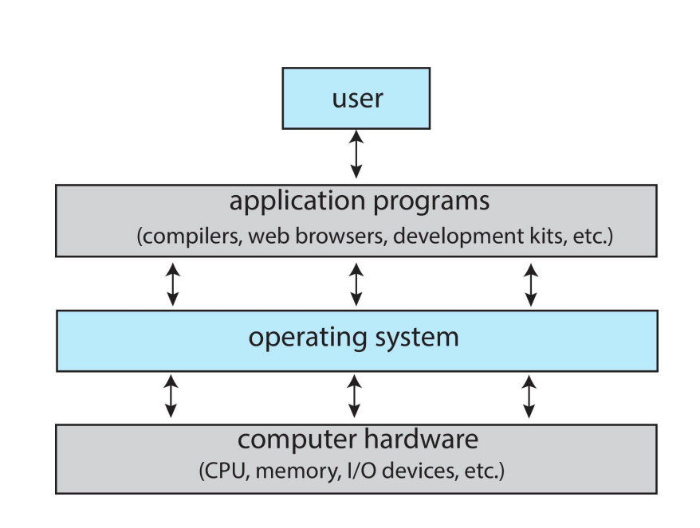

* Operating System provides Remote Login Facility to clients.
* **SSH 🡪 Secure Shell Server** is used to login on remote server.
* SSH for PUCIT : **172.16.0.21**
* **OS Memory:**

It is divided into two spaces:

1. **User Space:**

It is a memory area where processes execute.

It includes commands or operations that are given/done by user.

1. **Kernel Space:**

It is a memory area for running operating system kernel.

* User needs to ask kernel for everything.
* Kernel is responsible for everything.
* Every demand of user goes to OS/Kernel.
* Format of file depends on MS word, PowerPont, NotePad, etc.

**EXPECTATION OF KERNEL FROM PROCESSES, USER:**

1. One process should never READ/WRITE/USE address of other process.
2. When one process tries to READ/WRITE from memory of other process, **Segmentation fault/error** occurs. In this situation, OS kills the process.
3. Screen and keyboard collectively makes **TERMINAL**.

**EMBEDDED SYSTEM:**

A device without any operating system.

**PERIPHERAL DEVICE:**

A device which is outside from system.

**MULTI-CORE VS. MULTI-PROCESSOR ARCHITECTURES:**

* Multi-core architecture means more than one CPUs at a same location.
* Multi-processor architecture means more than one CPUs at different locations.

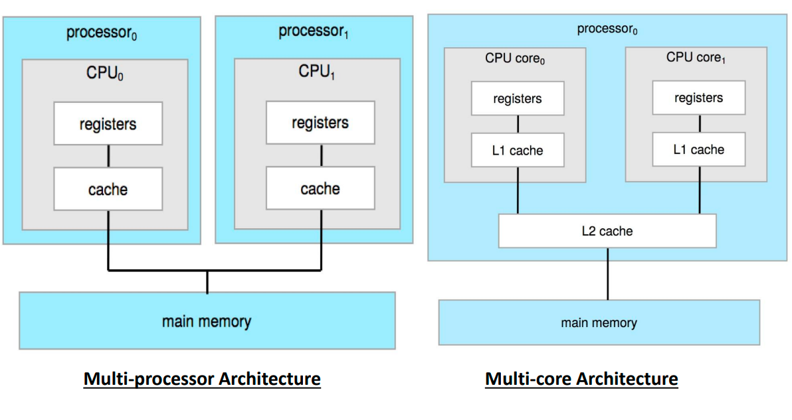

**COMPUTER SYSTEM:**

* CPUs and device controllers are connected through a common bus which provide access to shared memory.
* I/O devices and CPU execute concurrently.
* Each device controller has a local buffer.
* CPU moves data from main memory to local buffers and vice versa.
* Device controller informs CPU that it has finished its operation by causing an interrupt.

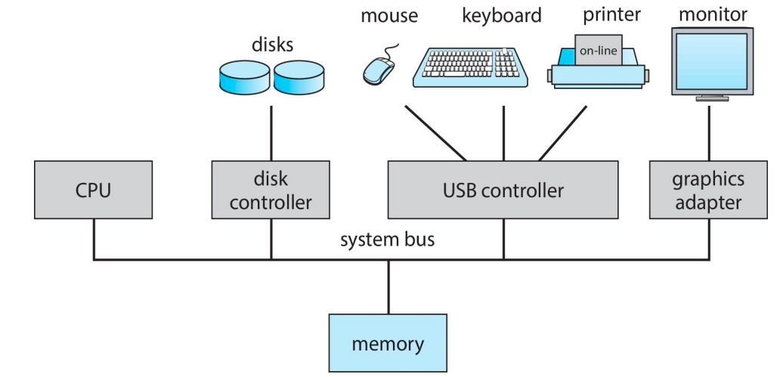

**IMPORTANT TERMS:**

1. **Interrupt:**

* Interrupt occurs by external event.
* It is a mechanism which occurs virtually in all computers to interrupt normal sequence of processor.

**SUB-ROUTINE/FUNCTION CALL VS. INTERRUPT**

|  |  |
| --- | --- |
| **FUNCTION CALL** | **INTERRUPT** |
| * Occurs due to execution of instruction. * It is predefined, so we already know how to handle it. * It returns address. * It restores the state of CPU but not from the exact point where it stopped. | * Occurs due to external event. * It is not predefined, so we have to decide at run time, how to handle it. * It restores the exact CPU state also the exact point where CPU stops. |

1. TRAP:

* An event which causes interruption but never restores/executes CPU state.

1. SIGNAL:

* It is a sign given by OS when processes want to communicate. OS decides whether processes can communicate and not.